Blue Rock Shoot
Comedy Showcase
Tuesday, June 28^{t h} 8:00 p.m.
Enjoy a night of food, drink and fun!

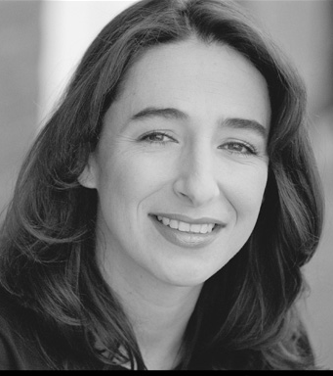
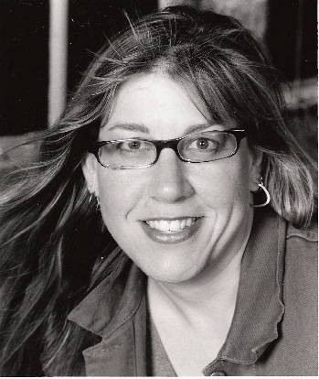
Starring

Tina Allen Denise Rob
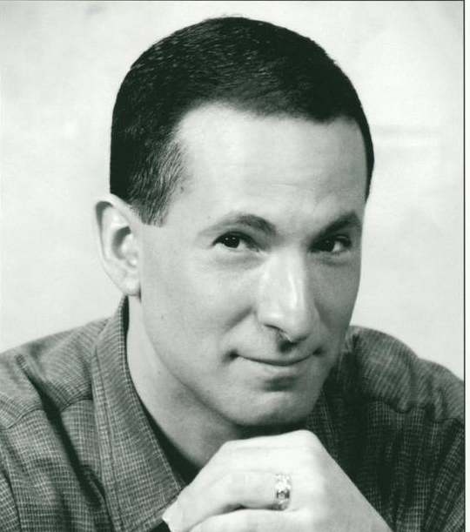


Jen Kober
Jeff with Meghan
Applebaum Justin Hill Hounshell

Blue Rock Shoot
14523 Big Basin Way

Saratoga, CA 95070
Contact Dan Edwards (408-398-9625) for more details

