Blue Rock Shoot
Comedy Showcase
Tuesday, Oct 11th 8:00 p.m.
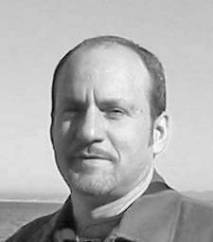
Enjoy a night of food, drink and fun!
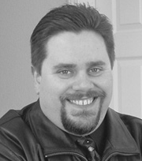
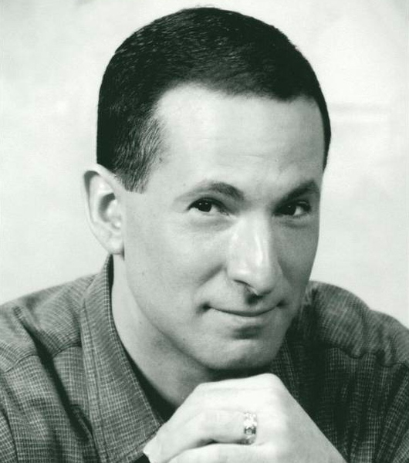
Starring

Robert Peterson Gary Penovich

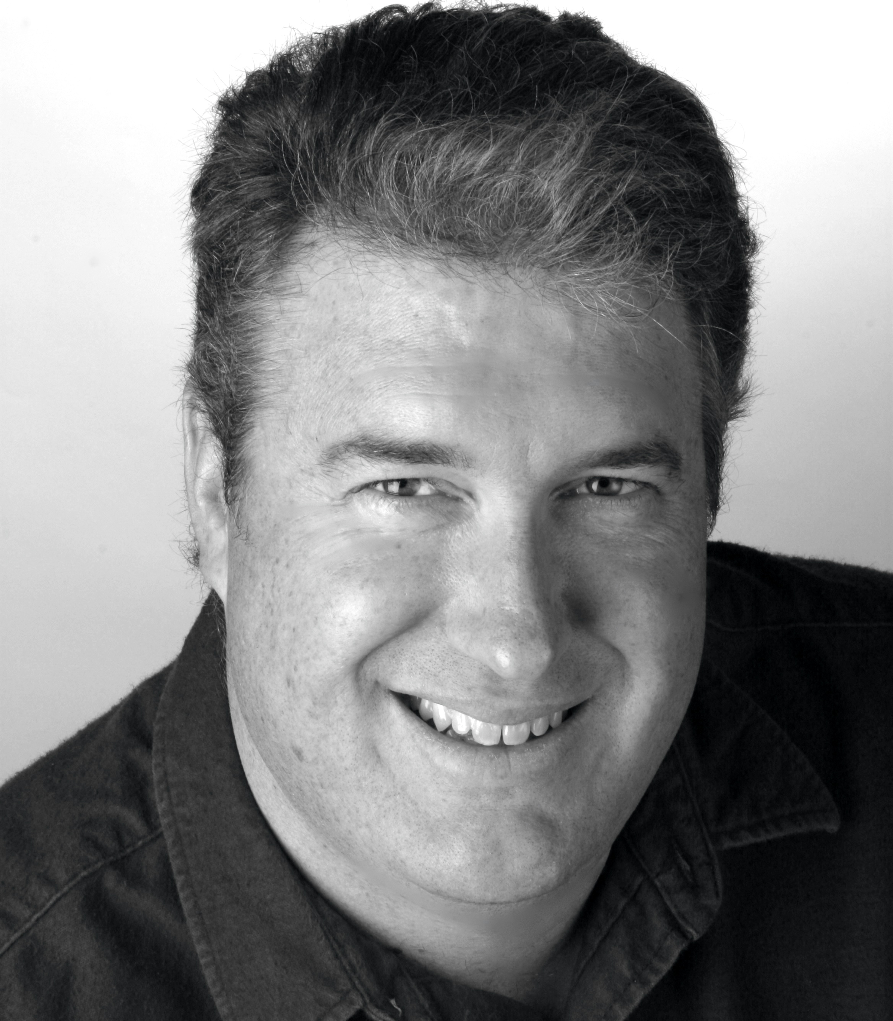
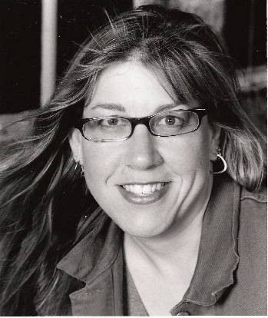
Jeff With
Applebaum
Dave McRae Denise Robichau
Blue Rock Shoot
14523 Big Basin Way

Saratoga, CA 95070
Contact Dan Edwards (408-398-9625) for more details

